DSA LAB 1

**Azhar Ali**

**023-23-0314**

**Sec A**

* Write a function in Java (or any language) to read a list of 10 integer numbers and arrange them in such a manner that all the even numbers start from the left and all the odd numbers start from the right.

Input: 1 2 3 5 7 2 2 7 8 9

Output: 1 3 5 7 7 9 2 2 2 8

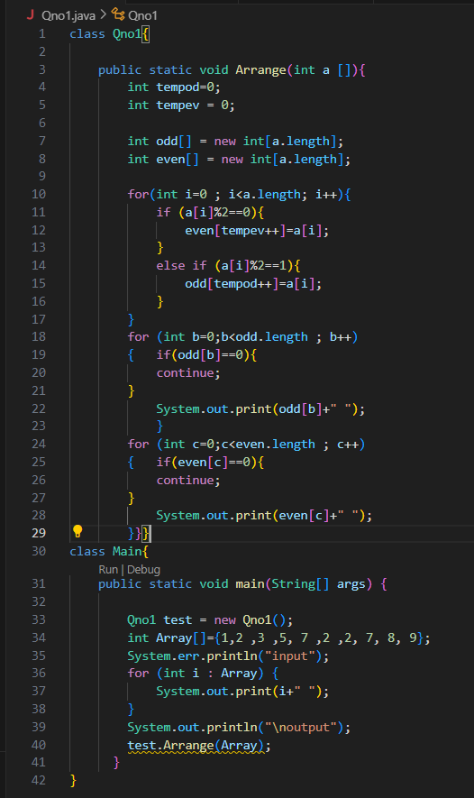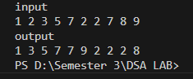

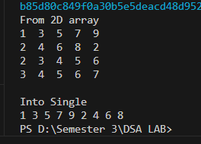2. Write a function named noDup() that takes a 2D array of size 4x5 and a 1D array of size 20. It should then copy all the elements of 2D array into 1D array but should avoid duplication.

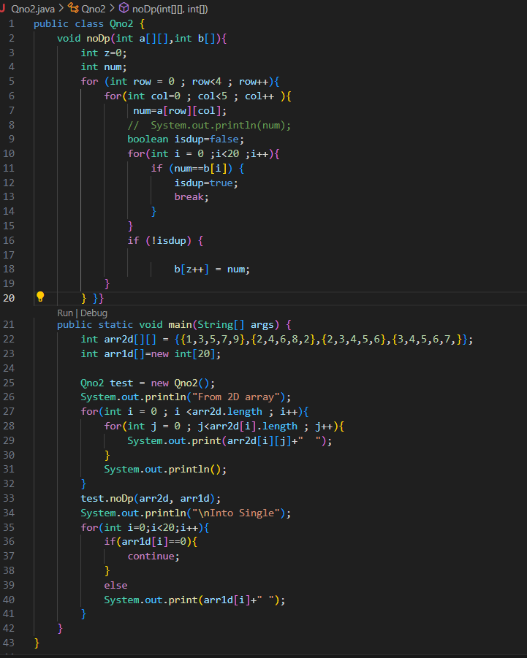

3. Create a file named NLArray.java and design following functions or performing NLP. -

* String [] wordTokenize (String fileName) ◊ Read any text file and return list of words from that file. (Ignore . , : and all these types operators)

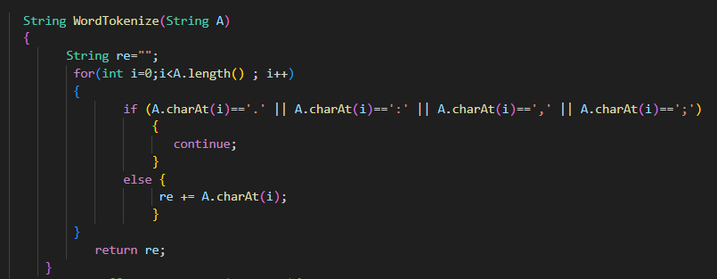

4. Design following methods in above same class NLArray.java for Image Cropping. - -

* void extractBoundaries (int arr[][]) ◊ This function should extract boundaries and print from arr (Boundaries include 1st row, 1st col, last row, last col).

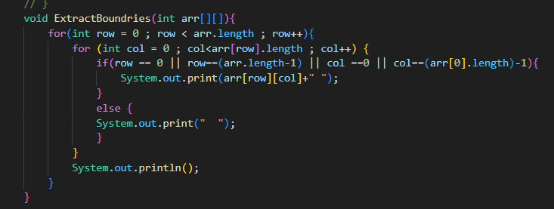

* void cropCenterPart (int arr[][]) ◊ This function should extract center part and print from arr, center part includes everything except Boundaries (Boundaries include 1st row, 1st col, last row, last col).

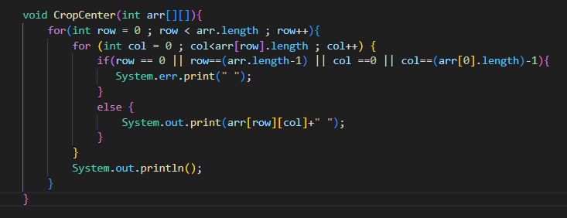s

* **MAIN Method And Output of Qno 3 and Qno 4**

